

Quality Assurance web site

Islam Khaled Mohamed 1112276 Ibrahim Ahmed Hussiny 1115836 Mohamed Moanis Abdellatif 1112632



December 27, 2015

**User manual**

1. Choose sign up from the navigation bar if you are a new user or sign in if you are a returned user.
2. At sign up you will be asked to insert some data needed for registration, insert them and then click register, you should recheck the website after some time to make sure that your registration has been accepted by site admin.
3. If you are a returned user select log in from the navigation bar, you will be asked to enter your credentials, enter them and then click submit, and if you submitted the right credentials you will be directed to your home page.
4. After signing in your home view varies according to the following roles
   1. Admin:
      1. You will see a list of pending users, and another one for all active users.
      2. Choose one of the pending users, his info will be shown and you can approve his registration and assign role to him.
      3. From your home page you can choose one of the users, and change his/her role.
   2. Instructor
      1. You will see list of your assigned courses, you can choose any of them, and insert files data of this certain course.
   3. Quality assurance member
      1. You will see list of departments in the faculty, and a progress bar shows the progress of each department, and another one at page bottom show faculty’s overall progress.
   4. Department Manager
      1. You will see list of courses assigned to your department.
      2. You can select one of the displayed courses, and delete the course from your department, or change course’s instructor.
   5. Pending user
      1. You will see a message telling you that the website admin hasn’t accepted your registration yet, check again after some time or contact the website technical support if the problem persists.
5. Through all the pages in the web site you can choose one of this options in the navigation bar
   1. Home: directs you to your home page.
   2. About: shows general information about the website.
   3. Contact: shows technical support contact info, if you face any problem regarding the website.
6. After finishing navigation through the web site, you can choose logout option from the navigation bar to end your session and leave the site.

**Site Map**

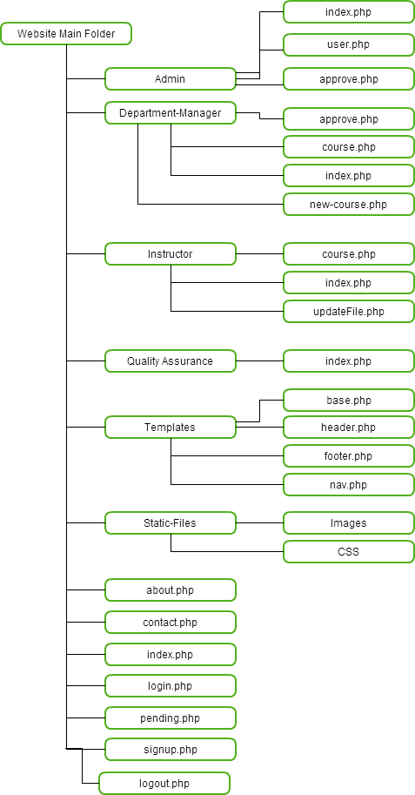

**Application files summary**

|  |  |
| --- | --- |
| File Name | Description |
| Index.php | Shows welcome message to users and navigation bar to go through the website. |
| About.php | Shows some information about CUFE. |
| Contact.php | Contact info to the website’s technical support. |
| Login.php | Shows form to take user’s credentials to login to the site. |
| Logout.php | Confirms user’s logout, and direscts him to website’s main page. |
| Pending.php | Previewed for pending users to tell them to wait till the admin assigns role to them. |
| Signup.php | Signup form for new users. |
| Admin/index.php | Main view for admin, previews list all users and pending users. |
| Admin/approve.php | Shows info of a pending user, and allows the admin to assign role to him/her. |
| Admin/user.php | Shows info of a certain user and allow admin to change his role. |
| Database/models.php | Contains the main functions needed to contact with the database. |
| Database/qadb2.sql | The database structure and relations. |
| department-management/index.php | Shows list of all courses related to the logged in department manager. |
| department-management/course.php | Shows all information of a certain course, and allows manager to assign or change its instructor, or deletes the course. |
| department-management/new-course.php | Allows the department manager to add new course to his department. |
| Instructor/course.php | Shows the information of a certain course given by the logged in instructor. |
| Instructor/index.php | Shows list of courses assigned to the logged in instructor. |
| Instructor/updateFile.php | Allows instructor to update course files. |
| quality-assurance/index.php | Main page for the quality assurance member, shows the list of departments with a progress bar of each department progress. |
| static-files/css | Directory contains the css files of the website. |
| Static-files/images | Directory contains the images used in the website. |
| Templates/base.php | Contains the main layout of the base body of all pages in the website. |
| Templets/footer.php | Contains the layout of the footer of the website pages. |
| Templets/header.php | Contains the layout of the website pages header. |
| Templets/nav.php | Contains the layout of navigation bar. |